深 圳 大 学 实 验 报 告

课程编号： 2801000049

课程名称： 机器学习

实验项目名称： Machine learning Task 1

学院： 电子与信息工程学院

专业： 电子信息工程

指导教师： 麦晓春

报告人： 古炜 学号： 2022280327 班级： 文华班

实验时间： 2024.03.08

实验报告提交时间： 2024.4.02

教务部制
1. Experimental Purposes and Requirements
(1) Be familiar with PCA and linear regression algorithms.
(2) Complete the programming tasks introduced in tutorials 1-5.
(3) Write a linear regression algorithm by yourself. - Use Boston House Dataset (506 samples and 13 feature variables), predict the value of prices of the house using the given features. - Split input data into training and testing sets (the testing set includes10% of the samples). - The output of the algorithm should include the model learned from the whole training set; the average mean squared error (MSE) on training set via 10-fold cross validation. For ridge regression model, determine the value of hyper-parameter via 10-fold cross validation.
(4) Write the experimental process and results into an experimental report. (strict content, abundant pictures and words).
- See if there are any missing values in the data.
- Exploratory data analysis (e.g., plot the distribution of the target variable, create a correlation matrix that measures the linear relationships between the variables and plot the correlation matrix, show the mean squared error (MSE) on testing set, plot a scatter plot between the original house price and predicted house prices).
(5) The source code should be submitted as an appendix (Just submit the source code of the regression algorithm)
2. Experiment Contents and Process
2.1 Experiment 1
(1) Experimental Contents/Introduction
- Be familiar with PCA and linear regression algorithms.
PCA: Principal Component Analysis (PCA), an unsupervised algorithm that does not rely on any category label information, is a commonly used linear dimensionality reduction method. The goal of this algorithm is to map some data from the original high-dimensional space to a lower dimensional space through a certain linear projection, and to preserve the information of the original data as much as possible in the projected dimension. Under the new dimension, variables are not correlated pairwise.
Linear regression: Linear regression is a fundamental regression analysis method aimed at modeling the relationship between one or more independent variables and a continuous dependent variable as a linear equation. This method can be used to predict the value of the dependent variable, as well as to describe the relationship between the independent variable and the dependent variable.
- Complete the programming tasks introduced in tutorials 1-5.
Tutorials 1 introduce some basic information about python, such as elementary data types, compound data types and so on.
Tutorials 2 introduce numpy and pandas libraries.
Tutorials 3 introduce data exploration, such as summary statistics, data visualization.
Tutorials 4 introduce data preprocessing.
Tutorials 5 introduce regression, including multiple linear regression, ridge regression, and Lasso regression.
- Write a linear regression algorithm.
Use Boston House Dataset (506 samples and 13 feature variables), predict the value of prices of the house using the given features. Calculate the average mean squared error (MSE) on training set via 10-fold cross validation.
(2) Methods
- Using the least squares method to solve the parameters of multiple linear regression:
For a sample with n features, its regression result is as follows:
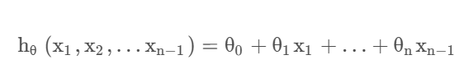
In this expression, θ is collectively referred to as the parameter of the model, where θ₀ is referred to as the intercept, and θ₁ –θ_{n} is referred to as the regression coefficient.
Now there are m samples, each with n-1 dimensional characteristics. Substituting all sample points into the model yields:
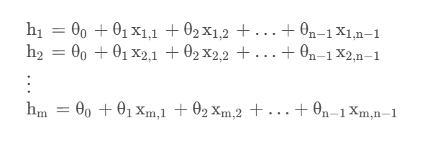
For the convenience of using a matrix representation, let x₀=1.
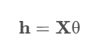
The objective loss function is represented by a matrix as:
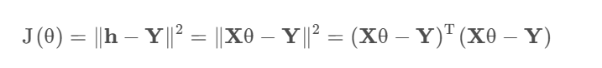
Also, if matrix A is symmetric:
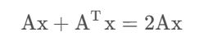
Simplify the objective function:
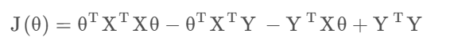
be θ Minimum value of:
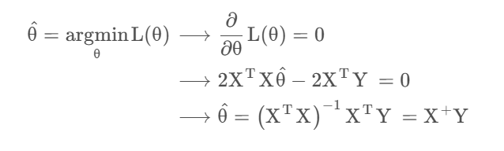
- 10-fold cross validation:
10-fold cross validation, the initial sampling is divided into 10 sub samples, with one individual sub sample retained as the data for validating the model, and the other 9 samples used for training. Cross validation is repeated 10 times, with each subsample validated once. The average result of 10 times or other combination methods are used to obtain a single estimate. The advantage of this method is that it repeatedly uses randomly generated sub samples for training and validation, with each result validated once.
(3) Data Collection, Preprocessing and Analysis
- Missing value:
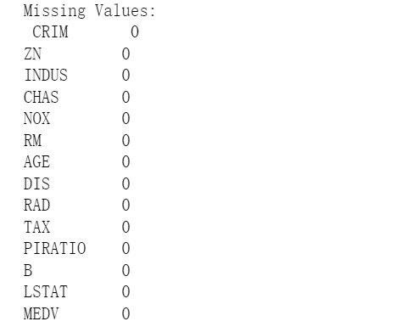
From the result, we can see that there are not missing in the data.
- The distribution of the target variable.
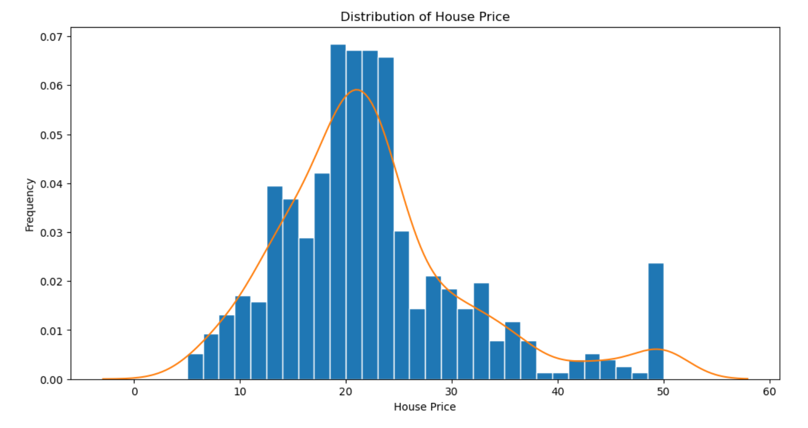
- Correlation matrix:
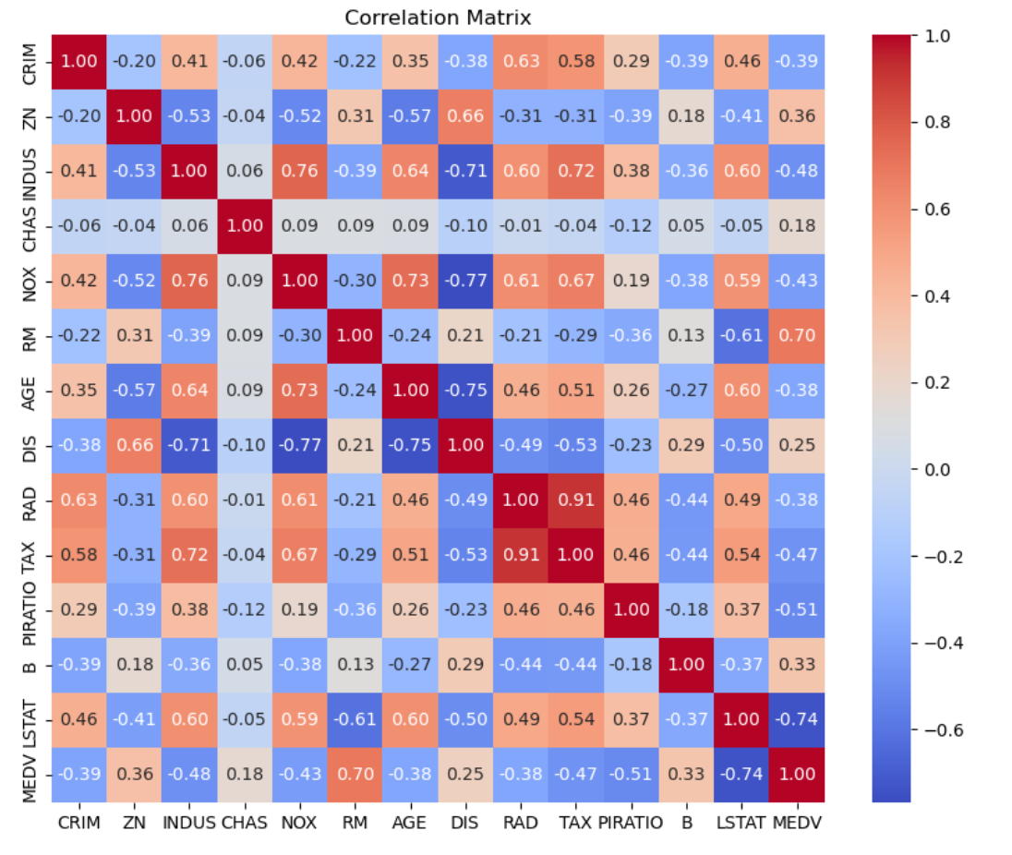
(4) Experimental Results and Analysis
-Model Coefficients:
Variable | Coefficient
CRIM | -0.120
ZN | 0.040
INDUS | 0.021
CHAS | 2.776
NOX | -18.585
RM | 3.756
AGE | 0.005
DIS | -1.471
RAD | 0.312
TAX | -0.012
PIRATIO | -0.948
B | 0.010
LSTAT | -0.550

-Linear regression model’s MSE from two different methods:
We can see that the MSE of the two methods is not significantly different.

2.2 Experiment 2
(1) Experimental Contents/Introduction
- Write a ridge regression model.
Ridge regression: A regularization penalty term (L2 norm regularization) is added to the cost function used in the model iteration process to limit the degree of matching between model parameters and abnormal samples, thereby improving the fitting accuracy of the model to the majority of normal samples and solving overfitting problems.

(2) Methods
In multiple regression, there may be multicollinearity issues between features, and using the least squares method to estimate coefficients may result in unstable coefficients, lacking stability and reliability.
To solve the above problems, we need to transform the ill posed problem into a well posed problem, add a small constant value λ to the diagonal elements of matrix X^{T}X, and then take its inverse to obtain the coefficients:
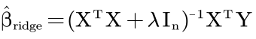
Subsequently, the cost function J_{β}(β) On the basis of RSS, a penalty for coefficient values has been added, which becomes:
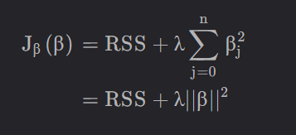
The matrix form is:
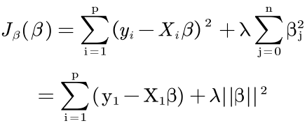
Ridge regression is an improved least squares estimation method, which obtains the regression coefficient at the cost of losing part of the information and reducing the accuracy by giving up the unbiased nature of the least squares method, which is a more practical and reliable regression method, and the fitting of the data with outliers is stronger than that of the least squares method.

(3) Experimental Results and Analysis
- Best Hyper-parameter (alpha) selected: 0.3
- Average MSE on Training Set (10-fold Cross Validation): 24.906993034823397

Evaluate the model:
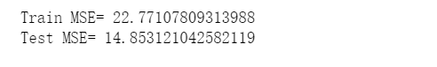

The scatter plot between the original house price and predicted house prices:
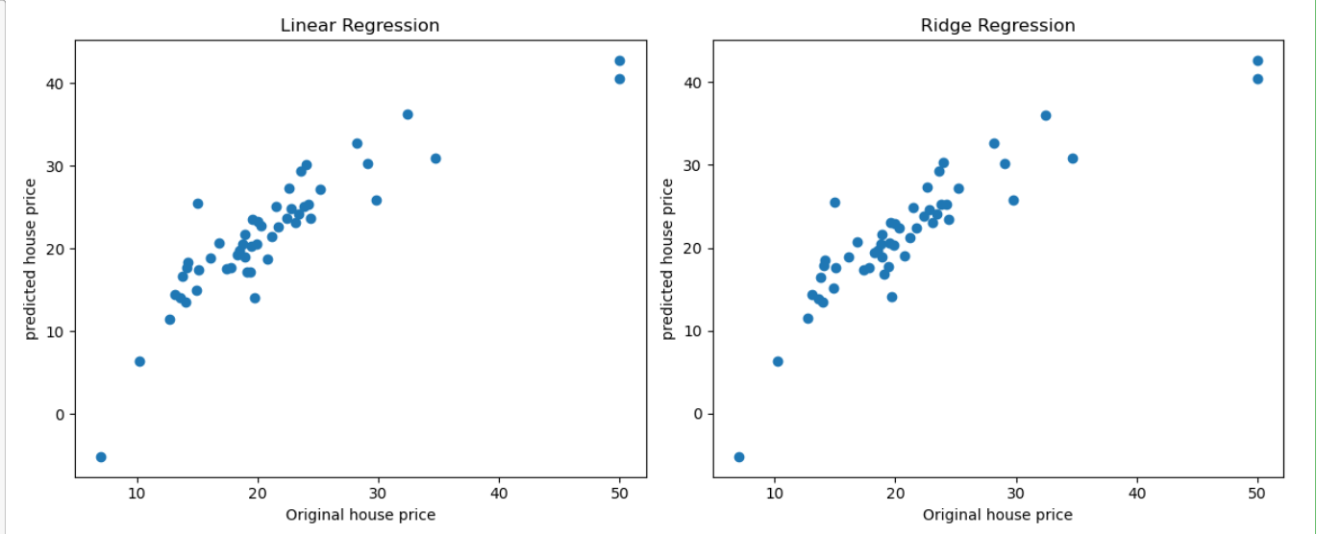

3. Discussion and Conclusions
Through this experiment, we conducted exploratory data analysis and linear regression modeling on the Boston housing price dataset.
We first checked the dataset for missing values, and fortunately, there were no missing values in the dataset, so there was no need for missing value processing. Subsequently, we divided the dataset into training and testing sets in a 9:1 ratio for model training and evaluation.
In terms of exploratory data analysis, we found that housing prices exhibit a roughly normal distribution and some outliers by plotting the distribution of the target variable (housing prices). The linear relationship between each feature variable and the target variable was analyzed using a correlation matrix. The results show that there is a significant linear correlation between certain characteristic variables and housing prices, such as a positive correlation between the number of rooms and housing prices, and a negative correlation between how many landlords in the region belong to low-income groups and housing prices.
In terms of linear regression modeling, models were established using ordinary linear regression and ridge regression, respectively. Ordinary linear regression uses the least squares method to determine the parameters and verifies the variance using the 10-fold cross method. Ridge regression determines the optimal hyperparameter value through 10-fold crossover to optimize the performance of the linear regression model. Finally, evaluate the model and calculate the MSE of the test set.
Through this experiment, I have learned the principles and algorithm implementation of linear regression, mastered the 10-fold cross validation method, and can apply it to the optimization of linear regression algorithms. Moreover, I have learned how to process and explore the analysis of datasets, and can apply linear regression and data analysis to daily life.

指导教师批阅意见：

成绩评定：

指导教师签字：
年 月 日
备注：
注：1、报告内的项目或内容设置，可根据实际情况加以调整和补充。
2、教师批改学生实验报告时间应在学生提交实验报告时间后10日内。

